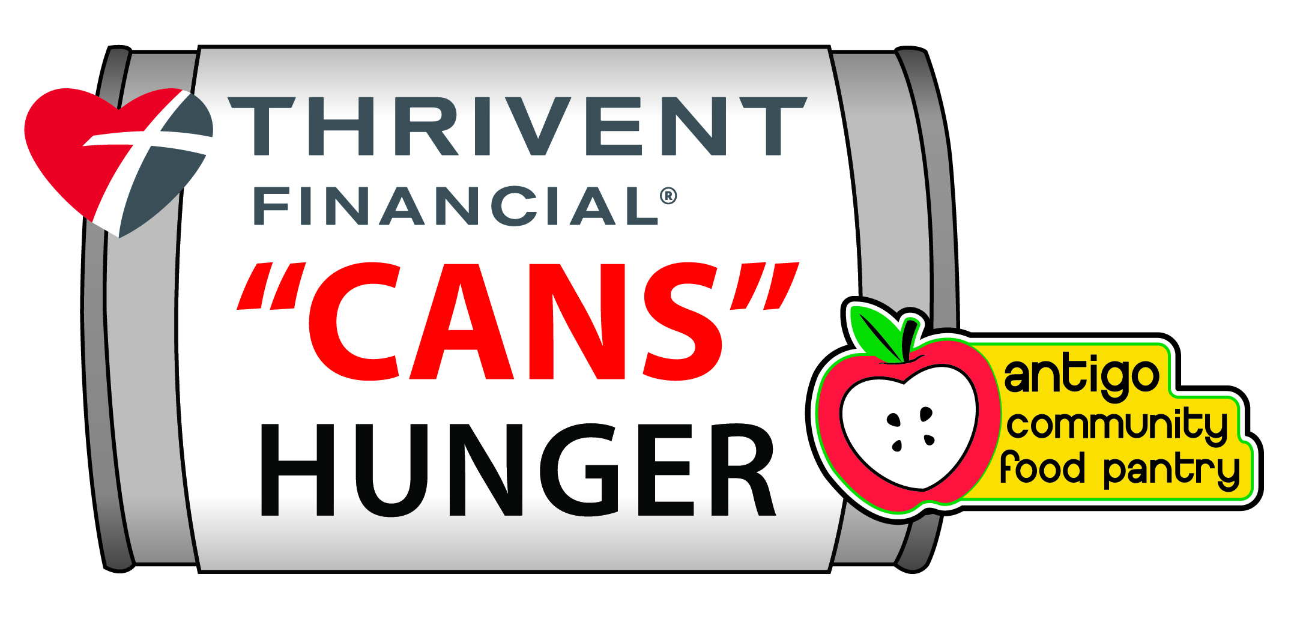
Frequently
Asked
Questions
Traveling trophies will be awarded in 4 categories:
“Antigo Heavyweight” People’s Choice Most Creative Best Collaboration
Heavyweight award will be given to the structure that weighs in with the highest number of pounds of donated materials used in construction. If you feel your structure may be in the running for Heavyweight, please contact Jean or Travis at Thrivent Financial so arrangements can be made for a “certified” weigh-in pickup after “de-construction”. The “People’s Choice” award will be given to the structure that receives the most votes from the general public during the viewing week, October 5th thru October 11th. New this year….voting will take place via the internet. A member of the TCH committee will monitor your construction progress so a picture can be taken and added to the “voting page” on the new Food Pantry website at www.antigofoodpantry.com. A panel of impartial judges will determine the “Most Creative” award and the “Best Collaboration” award during the viewing week, October 5th thru October 11th. Winners of all categories will be announced at the Awards Picnic on Wednesday, October 14th at Lake Park at 5 pm. All participants are invited….please make sure you have someone representing your “build” team, as awards are presented at that time.
- A business /organization can choose to erect the sculpture at a site of their choosing and must indicate location on the registration form.
- Signage will be provided at your business/organization to promote your participation in the event.
- Each winner will receive a ONE-OF-A-KIND traveling trophy specifically designed for Thrivent “Cans” Hunger. A structure cannot win more than 1 traveling trophy per year.
- A team may be comprised of one or more businesses/organizations. In the spirit of competition, we encourage organizations to collaborate with others.
- An apple ( the ACFP logo) must be included somewhere in your construction in order to receive 1 point in the judging rubric. Hiding the apple in a very creative way will be worth an additional point. It does not have to be made of cans. It will be fun for the public to search for the apple during viewing week—similar to “Where’s Waldo?”
- All cans will be picked up by the Food Pantry on Monday, October 12th at your build site.

