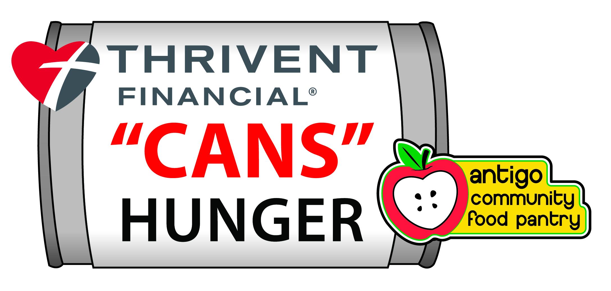

Build begins Saturday, September 26 and continues through Sunday, October 4, 2015

The Pinnacle Team of Thrivent Financial is again partnering with the
ANTIGO COMMUNITY FOOD PANTRY to coordinate the collection of much needed food items for the 2015 holiday season.

Your involvement has resulted in 10 tons of food collected over the first 2 years….please consider joining us in 2015!

Construction Rules & Regulations

A.) AWARDS

1.) Traveling Trophy Awards will be given in the following four categories:
“Antigo Heavyweight” People’s Choice Most Creative Best Collaboration

2.) The “Heavyweight” award will be given to the structure that weighs in with the highest number of pounds of donated materials that were used in construction. Certification of the weigh-in will be coordinated by the team leader, Thrivent Financial and food pantry volunteers after “de-construction.” Questions can be directed to Jean Greening or Travis Rose by calling the Thrivent office at
715-623-5279.

3.) NEW CHANGE….The “People’s Choice” award will be given to the structure that receives the most “votes” from the general public during the on-line viewing and voting week, October 5th thru October 11th . This year, we will have the voting take place on line at the AntigoFoodPantry.com website that will be up and running by 9/1/2015. A representative from the Thrivent “Cans” Hunger committee will contact your organization to arrange a picture of your structure to be added to the website prior to the voting dates.

4.) The “Best Collaboration” award will be decided by a panel of impartial judges who will take into account how each separate organization was involved, i.e. providing cash or building site for the construction, designing the structure, actual erection of structure, etc.

5.) A panel of impartial judges will also determine the “Most Creative” award during the viewing week, October 5-11th. You will be contacted to set a time that is most convenient for your organization for the Judges to visit and make their assessment. Your structure will be judged on 5 criteria:
- Originality/Creativity
- Use of Color
- Use and creativity incorporating the food pantry’s “Apple” logo in the structure (does not have to be made of cans)
- Complexity
- Overall Effect/Use of Scale
Winners of all categories will be announced at the Awards Picnic on Wednesday, October 14th at Lake Park beginning at 5PM.

B.) CAN & MATERIAL RESTRICTIONS
- There is no size limit to the structure you build.
- Participating teams are responsible for obtaining their own supply of cans. Aluminum and steel food cans of all sizes may be used. Some food manufacturers have begun using plastic cans. If you are using plastic, be certain they can support the pressure from the cans above.
3.) No beverages, except water bottles.
4.) No “junk food”.
5.) No open or exposed food. (attracts vermin)
6.) Cans must be full, unopened, with labels intact and legible. Labels may not be covered, stripped off or altered in any way. Remember, this food will be distributed to food pantry clients after the event.
7.) Boxed and bagged food items are permissible such as rice, beans, etc.
8.) Props are permitted but should be used only when absolutely necessary. Judges prefer pure food structures. Try to solve all design problems with food items. All things being equal, a structure with props will get fewer points when judged against one without props. (Example: a structure that has eyes. One entry uses black cans to make eyes; another entry cuts out black circles of paper for eyes and pastes them on their cans. Once those judging see that eyes can be made with cans or a food product, any entry using non-food materials is less likely to win.)
9.) Since an apple is part of the ACFP’s logo, an apple must be incorporated into the design of your structure. It may be very small, and does not have to be made out of cans. One point will be given for having an apple in the structure design and one point will be given for a very creative way of hiding the apple. It will be fun for the public to “find the apple” similar to “Where’s Waldo?”
10.) No permanent adhesives may be used. Any temporary adhesives such as hot glue that was used during construction should be removed during “de-construction.”
11.) All teams should be mindful that labels must remain intact during de-construction. Be careful not to
use excessive amounts of tape.

C.) TEAMS
1.) Teams may have as many members as are interested in participating, but must include at least one individual to act as the “team leader.” The team leader will be the contact person for Thrivent “Cans”
Hunger and will be responsible for receiving and disseminating all information.
2.) We encourage team members to arrange for a tour of the Antigo Community Food Pantry to help them understand the scope of hunger in our community and how their project enhances and compliments efforts already in place. Tours can be arranged by contacting Kris Page at 715-216-2854 or emailing krispage2@gmail.com or Kathie Baginski at 715-627-7647 or emailing jork.bags@frontier.com.

D.) BUILD WEEK
1.) Build Week will take place at your business or location of your choice from Saturday,
September 26th through Sunday, October 4th.
2.) No actual construction may begin prior to 7:00 AM on Saturday, September 26th. However, cans may be collected and brought to your build location prior to Build Week. Design planning and “practice construction” off site are recommended. Don’t let the competition get a leg up on you!

DE-CONSTRUCTION TIPS
1.) Save your boxes as you construct. Each entry must be taken down and packed in boxes for transport to ACFP. Times of delivery will be arranged by your team leader and volunteers at the food pantry.
2.) If you think you may be in contention for the “Antigo Heavyweight” award, please contact Jean or Travis at the Thrivent Financial office at 623-5279.
3.) Teams are encouraged to enlist as many volunteers as possible to help with the “de-construction” activities. Volunteers may include friends, parents and other individuals willing to assist, even though they had not previously participated in construction. Please keep in mind that “de-construction” of your entries must be conducted in the same structured and organized manner as when they were built. Teams should exercise caution in assuring that labels are not torn and cans are not damaged. A TCH committee member will contact you to arrange pickup of the de-constructed cans.

Thank you for participating in Thrivent “Cans” Hunger!

